ANNEX AO – THE GOLD STANDARD MICRO-PROGRAMME ACTIVITY DESIGN DOCUMENT TEMPLATE (VPA-DD)

CONTENTS

A. General description of micro-programme activity (VPA)

B. Eligibility of VPA and Estimation of Emission Reductions

C. Stakeholder comments

Annexes

Annex 1: Contact information on entity/individual responsible for the VPA
Annex 2: Information regarding public funding
Annex 3: Scan of list of participants to the Stakeholder consultation
Annex 4: Scans of feedback received
Annex 5: Baseline report

SECTION A. General description of micro-programme activity (VPA)

A.1. Title of the micro-scale VPA:

Title: GS 2504 Voluntary Gold Standard Multi-country Improved Cookstove PoA - Flamingo
Cookstove Project VPA 5
Version: 01
Date: 28/12/2016

A.2. Description of the micro-scale VPA:

The purpose of this project activity is to distribute approximately 2,400 fuel-efficient firewood cookstoves in the Republic of Kenya (Kenya), particularly to employees of Flamingo (Flamingo Horticulture Ltd.) in the Mt. Kenya farms and members of communities neighboring the farms. The project activity will replace traditional three stone fires or conventional stoves without grate or chimney with Zoom Dura firewood cookstoves.
Stoves distributed under this project activity are portable devices serving domestic firewood users. These cookstoves are more efficient in transferring heat from the fuel to the pot, thus saving firewood compared to the traditional three stone fires and conventional stoves without grate or chimney currently used by households.
Technical description of stoves
Stove Manufacturer: EcoZoom
Stove Model: Zoom Dura with pot skirt
Thermal Efficiency: 38% (with pot skirt), established
by Aprovecho Research Center

Emission reductions achieved by this VPA are limited to a maximum of 10,000 tCO₂e per year, and the project activity comprises of independent sub-system. The VPA is estimated to averagely generate greenhouse gas emission reductions of 8,503 tCO₂e per year, thus it is within the threshold of the micro-scale.

Contribution to sustainable development

- The project activity will result in greenhouse gas emission reductions because it will reduce the consumption of non-renewable biomass in Kenya where the biomass harvested for fuel use is typically non-renewable.
- Users (especially women and children) will be less exposed to harmful air pollutants through reduced emission of carbon monoxide and particulate matter. Air pollution from cooking with solid fuel is a key risk factor for childhood pneumonia as well as many other respiratory, cardiovascular and ocular diseases.
- Biodiversity will be improved as the project activity reduces pressure on remaining forest reserves in Kenya. Firewood for domestic energy supply is recognised by the Government of Kenya as being one of the major factors driving deforestation in the country.
- The livelihoods of poor families will be improved since the project stoves reduce the amount of money spent for buying firewood and/or the time spent on collecting firewood. Reduction in firewood consumption will provide opportunities for productive activities and education.
- The project activity will facilitate capacity development among the stove users. Trainings on sustainability and environmental protection will help stove users to move towards sustainable access to firewood.

A.3. Entity/individual responsible for the micro-scale VPA:
The coordinating/managing entity of the VPA is South Pole Carbon Asset Management Ltd. and all contact details are provided in Annex 1.

A.4. Technical description of the micro-scale VPA:

A.4.1. Identification of the micro--scale VPA:

A.4.1.1. Host Party:
Republic of Kenya
A.4.1.2. Geographic reference or other means of identification allowing the unique identification of the micro--scale VPA (maximum one page):
The cookstoves will be distributed to end users in villages surrounding the Flamingo farms around Timau (Mt. Kenya). The villages include but are not limited to Sirimon, Kalalu, Mairo-nane, Kua-makara, Katheri, Riverside, Ngusishi and Kua-nganga.

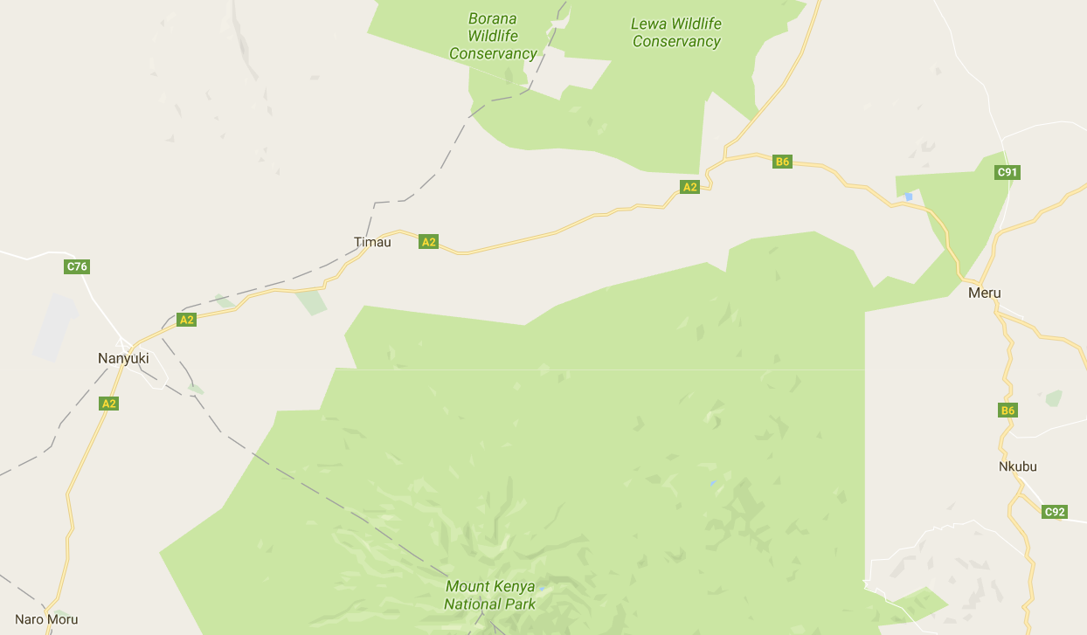
The project area is limited by S 0.01000° to the South and N 0.15000° to the North, and by 37.0000° to the West and 37.50000° to the East.

A.4.2. Duration of the micro--scale VPA:

A.4.2.1. Starting date of the micro--scale VPA:
TBD – Sales of first improved cookstove (expected in mid-May 2017)

A.4.2.2. Expected operational lifetime of the micro--scale VPA:
3 x 7 = 21 years

A.4.3. Choice of the crediting period and related information:
Renewable crediting period

A.4.3.1. Starting date of the crediting period:
01/07/2017

A.4.3.2. Length of the crediting period, first crediting period if the choice is renewable CP:
7 years

A.4.4. Estimated amount of emission reductions over the chosen crediting period:
Year | Estimation of  project activity  emission  (tCO₂) | Estimation of  baseline emissions  (tCO₂) | Estimation of  leakage  (tCO₂) | Estimation of overall emission reductions  (tCO₂)
01/07/2017 to 31/12/2017 | 0 | 4,868 | 244 | 4,624
01/01/2018 to 31/12/2018 | 0 | 9,511 | 476 | 9,035
01/01/2019 to 31/12/2019 | 0 | 9,287 | 465 | 8,822
01/01/2020 to 31/12/2020 | 0 | 9,064 | 454 | 8,610
01/01/2021 to 31/12/2021 | 0 | 8,840 | 442 | 8,398
01/01/2022 to 31/12/2022 | 0 | 8,616 | 431 | 8,185
01/01/2023 to 31/12/2023 | 0 | 8,392 | 420 | 7,972
01/01/2024 to 31/06/2020 | 0 | 4,084 | 205 | 3,879
Total | 0 | 62,662 | 3,137 | 59,525

A.4.5. Public funding of the VPA:
The project does not receive any ODA funding (see ODA declaration form).

A.4.6. Confirmation that micro--scale VPA is neither registered as an individual GS project activity or with any other standard or is part of another Registered PoA:
This VPA is neither registered as an individual Gold Standard project or with any other standard or is part of another registered PoA.

SECTION B. Eligibility of micro--scale VPA and Estimation of emissions reductions

B.1. Title and reference of the Registered PoA to which micro--scale VPA is added; title of baseline and monitoring methodology applicable to the VPA:
Micro-scale PoA:
Voluntary Gold Standard multi-country improved cookstove programme of activities (GS 2504)
Gold Standard methodology:
“The Gold Standard simplified Methodology for Efficient Cookstoves, Version 2.2”
B.2. Justification of why the micro--scale VPA is eligible to be included in the Registered PoA:
No. | Eligibility criteria |  | Means of proof | Confirmation
 | Description | Conditions to be met | Means of proof | Confirmation
1 | Boundary and location of the project activity | The project activity is located within the boundary of one of the host parties listed in section A.4.1.1 of the PoA DD. | The geographical boundary of this VPA is in Kenya which is part of the PoA boundary (section A.4.1.1 of the PoA DD). | Yes
2 | Project technology | - The project activity should involve distribution of improved cooking stoves with thermal efficiency of at least 20%.  - Information about compliance should be demonstrated by each VPA DD  - Check if any EIA or no objection certificate is required for this technology or project. | - The type of stove distributed (Zoom Dura) under this VPA is an improved cookstove with thermal efficiency of 38% which is greater than 20%.  - The project stoves comply with current regulations in Kenya. | Yes
3 | Avoiding double counting | The project activity includes a means of uniquely identifying the stoves to be distributed and the end-users who will receive stoves. This would also ensure that there is no double counting of the VPA being implemented in any other PoA or single project activity.  Also a thorough analysis of available databases (GS, VCS, UNFCCC) to check whether the VPA is included in any other voluntary market or CDM project activity. | A unique serial ID number for each stove distributed will be recorded.  Distribution records showing end user details, including name and address, will be collected along with stove IDs and recorded in a database.  Thorough analysis was done at the UNFCCC and VCS websites. This project activity it is not part of any other single project or PoA. | Yes
4 | Fuel usage | The improved cookstove (ICS) distributed uses firewood and replaces a system that previously used non-renewable firewood. | The ICS distributed under this VPA uses firewood to reduce the use of non-renewable firewood in baseline scenario. | Yes
5 | Microscale limit for VPAs | The aggregated annual emissions reductions for all the systems involved shall be not greater than 10,000 tCO₂e | This VPA is estimated to generate 8,716 tCO₂e per year, which is below the 10,000 tCO₂e threshold.  In case the VPA exceeds the applicable limit, the claimable emission reduction for this VPA shall be capped at 10,000 tCO₂e. | Yes
6 | Project activity crediting period does not exceed micro-scale PoA life | The duration of the crediting period of each VPA to be included in the micro-scale PoA shall not exceed the end date of the registered micro-scale PoA. | The duration of the VPA’s crediting period is 7 years, renewable. The end date for which ERs can be credited will be not later than 28 years after the date of registration of the micro-scale PoA. | Yes
7 | Additionality | The micro-scale project activity is an emission reduction project in which each of the independent  subsystems /measures achieve annual emission reductions equal to or less than 600 tCO₂  or annual energy savings equal to or less than 600 MWh or installed capacity is less than 1500 kW for households/ SMEs / communities. | The emissions reduction capacity of each ICS is 3.68 tCO₂e per year which is less than 600t CO₂e and thus the VPA is additional. | Yes
8 | LSC | VPA may apply any of the following approaches  a) Grouped LSC  The project to be apply the group LSC shall comply with the following conditions:  - Must be from the same host country boundary,  - they will apply the same technology (firewood cook stoves),  - similar distribution mechanism shall be employed,  - the VPAs should be implemented within 3 years from the date of grouped LSC approval.  b) LSC at VPA level  In case a VPA cannot apply grouped LSC, it needs to conduct LSC at VPA level. | A physical LSC meeting was conducted at project activity level in Kenya on November 15th, 2016 and reported in section C of this VPA DD. | Yes
9 | Ownership of emission reductions can be clearly demonstrated | Only project activities which can clearly demonstrate transfer of ownership of credits from end-users to CME can be included. | Contracts have been signed between all project participants and CME, within which the ownership rights and selling rights of the emission reductions resulting from this project activity are clearly defined.  End users sign a carbon right waiver (integrated in the sales form) in order to transfer the carbon rights to the CME. | Yes
10 | Baseline | ICS replacing the following:  - Baseline fuel is firewood  - The baseline stove is a three stone fire or a conventional device without a grate or a chimney  - Project activity must demonstrate that the stoves being introduced are firewood burning stoves only | Baseline stoves are three stone fires or conventional stoves without grate or chimney with firewood.  Stoves distributed are firewood stoves. | Yes
11 | Prior consideration | Retroactive projects need to demonstrate prior consideration of carbon revenues irrespective of LSC (or group LSC) being done or not. | LSC was submitted before the start of this VPA (i.e. this VPA classifies for the regular project cycle). | Yes
12 | Start date of VPA | Documentary evidence on the start date of the VPA | The start date of the VPA is the date when the first stove is sold (TBD). | Yes
13 | Target group | Target group consists of households/communities in rural area and distribution mechanism | Target group are rural households around the Flamingo farms at Mt. Kenya | Yes
14 | Use of baseline cookstoves | Projects can use baseline cookstoves as a backup or auxiliary as long as a mechanism is put into place to encourage the removal of old cookstove. | The use of the baseline cookstoves is tracked by monitoring the parameter DF_{P,stove,y}. | Yes
15 | ODA | - Projects should not receive ODA funding  - In case any project is receiving a funding from Annex 1 country, then VPA has to demonstrate that funding from Annex 1 country does not lead to ODA diversion. | No public funding is used for the implementation of this VPA. Still, the ODA declaration form is provided in Annex 2. | Yes

B.3. Assessment and demonstration of additionality of the micro--scale VPA:
B.3.1 Description of how the anthropogenic emissions of GHG by sources are reduced as per the eligibility criteria defined in the registered micro-programme (when Additionality is demonstrated at the micro- programme level):
The current practice is cooking on traditional three stones fires or conventional stoves without grate or chimney. A lot of heat is lost to the surrounding area, hence a lot of firewood is required for cooking. Without the project activity, this would be the continued practice.
The efficient firewood cookstoves on the other hand are more efficient in transferring heat from the fuel to the pot, thus saving firewood compared to the traditional three stone fires or conventional stoves without grate or chimney. Therefore, by reducing the total amount of firewood required for cooking, the amount of GHG emitted into the atmosphere is reduced.
B.3.2 Description of how the anthropogenic emissions of GHG by sources are reduced below those that would have occurred in the absence of the registered micro-scale project activity (when Additionality is demonstrated at the activity level):
Each unit in the VPA-DD will reduce less than 600 MWh per year. Each cookstove is reported to have on average 3.68 tCO₂ emission reduction.

B.4. Description of the sources and gases included in the project boundary and proof that the micro--scale VPA is located within the geographical boundary of the registered PoA.
Source |  | GHGs | Included? | Justification/Explanation
Baseline | Combustion of non- renewable biomass for cooking | CO₂ | Yes | Important source of emissions
Baseline | Combustion of non- renewable biomass for cooking | CH₄ | Yes | Minor source of emissions
Baseline | Combustion of non- renewable biomass for cooking | N₂O | Yes | Minor source of emissions
Project | Combustion of non- renewable biomass for cooking | CO₂ | Yes | Important source of emissions
Project | Combustion of non- renewable biomass for cooking | CH₄ | Yes | Minor source of emissions
Project | Combustion of non- renewable biomass for cooking | N₂O | Yes | Minor source of emissions

B.5. Emission reductions:

B.5.1. Data and parameters that are available at validation:

Data / Parameter: | EF_{b,fuel,CO2}
Data unit: | tCO₂/tonne of firewood
Description: | CO₂ emission factor arising from use of firewood in baseline scenario
Source of data used: | IPCC default values, table 1.4 of chapter 1 of Vol.2, 2006 IPCC Guidelines for National Greenhouse Gas Inventories
Value applied: | 1.747
Justification of the choice of data or description of measurement methods and procedures actually applied: | Default value as per applied methodology
Any comment:

Data / Parameter: | EF_{fuel,non-CO2}
Data unit: | tCO₂/tonne of firewood
Description: | Non-CO₂ emission factor arising from use of firewood in baseline scenario
Source of data used: | IPCC default values, table 2.9 of chapter 2 of Vol.2, 2006 IPCC Guidelines for National Greenhouse Gas Inventories.
Value applied: | 0.455
Justification of the choice of data or description of measurement methods and procedures actually applied: | Default value as per applied methodology
Any comment:

Data / Parameter: | f_{NRB,y}
Data unit: | Fractional non renewability
Description: | Non-renewability status of wood fuel during year y
Source of data used: | Default NRB value provided by the CDM executive board and endorsed by Kenya, date of acceptance 19 December 2012.
Value applied: | 0.92
Justification of the choice of data or description of measurement methods and procedures actually applied: | Default value
Any comment:

Data / Parameter: | η_{b}
Data unit: | Fraction
Description: | Efficiency of the cookstoves being used in the baseline scenario
Source of data used: | Gold Standard Simplified Methodology for Efficient Cookstove, ver. 2.2
Value applied: | 10%
Justification of the choice of data or description of measurement methods and procedures actually applied: | Default value as per the applied methodology: “A default value of 10% shall be used if the replaced cookstove is a three stone fire, or a conventional device without a grate or a chimney, i.e. with no improved combustion air supply or flue gas ventilation.”
Any comment:

Data / Parameter: | η_{p}
Data unit: | Fraction
Description: | Efficiency of the cookstove being used in the project scenario
Source of data used: | EcoZoom, Aprovecho Research Center test report
Value applied: | 38%
Justification of the choice of data or description of measurement methods and procedures actually applied: | Value for applied project stove: Zoom Dura with pot skirt
Any comment:

Data / Parameter: | DF_{n}
Data unit: | Fraction
Description: | Discount factor to account for efficiency loss of project cookstoves
Source of data used: | Gold Standard Simplified Methodology for Efficient Cookstove, ver. 2.2
Value applied: | Annual Default value: 0.99, i.e. 1% efficiency loss per year
Justification of the choice of data or description of measurement methods and procedures actually applied: | Annual application of the discount factor
Any comment: | This default can be used if stoves are found in good condition during annual survey.  During annual surveys, if it is found that project stoves are not in working conditions, the proportionate population of project cook stoves should be excluded from the project database until these cookstoves are replaced with new cook stove.

Data / Parameter: | B_{b,y}
Data unit: | Tons of firewood per household per year
Description: | Firewood consumption for cooking in the baseline
Source of data used: | Baseline survey (see Annex 5)
Value applied: | 4.22
Justification of the choice of data or description of measurement methods and procedures actually applied: | A survey was carried out amongst randomly selected target end users to determine the firewood consumption in the baseline scenario. Following the guidance in the methodology, the minimum sample size of 100 was chosen. In total, the baseline firewood consumption was determined from data of 132 households.
Any comment:

B.5.2. Ex-ante calculation of emission reductions:

The emissions reductions are calculated as follows:
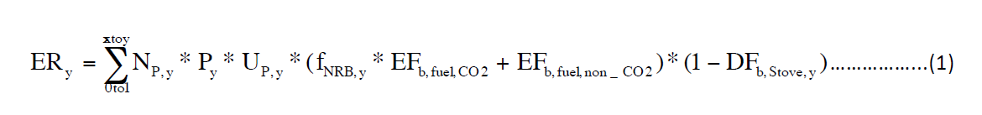
Where:
N_{p,y} Number of project cookstoves of each age group operational in the year y
P_{y} Quantity of firewood that is saved in the year y (tons per household per year y)
U_{p,y} Usage rate for project cookstoves in the year y, based on adoption rate and drop off rate revealed by usage surveys (fraction) (conservative estimation: 80%)
f_{NRB,b,y} Fraction of biomass, used in the year y for baseline scenario, which can be established as non-renewable (Default value of 0.92 applied as provided by the CDM executive board and endorsed by Kenya on 19th September 2012).
EF_{b,fuel,CO2} CO₂ emission factor of firewood that is substituted or reduced.
(Default value for wood fuel 1.747 tCO₂/ton of wood)
EF_{b,fuel,non-CO2} Non-CO₂ emission factor of firewood that is substituted or reduced.
(Default value for wood fuel 0.455 tCO₂/ton of wood)
DF_{b,stove,y} Usage of baseline cookstoves during the year y (fraction) in project scenario (conservative estimation: 0.25)
x y – 1
y Year of the crediting period

Quantity of firewood that is saved (P_{y}) is estimated as follows:
Where:
B_{b,y} Quantity of firewood consumed in baseline scenario during year y
(4.22 tonnes per household per year)
η_{p,y} Efficiency of project cookstove in year y (fraction)
η_{b} Efficiency of the baseline cookstove being replaced (fraction).
A default value of 10% is applied as the replaced cookstove is a three-stone fire or a conventional stove without grate or chimney
Determination of quantity of fire wood consumed in the baseline (B_{b,y}):
Option (b) of section 4.2 of the methodology was used to determine the average annual consumption of firewood per household (tonnes/year). A survey was carried out amongst randomly selected target end users to determine the firewood consumption in the baseline scenario. Following the guidance in the methodology, the minimum sample size of 100 was chosen (Project target population > 1000 Minimum sample size 100). In total, the baseline firewood consumption was determined from data of 132 households. And the average annual consumption of firewood per household in the baseline is 4.22 tonnes per household per year.
Determination of project cookstove efficiency:
Where:
η_{p,y} Efficiency of project cookstove in year y (fraction)
η_{p} Efficiency of project cookstove (fraction) determined at the start of the project (38%)
DF_{η} Discount factor to account for efficiency loss of project cookstove per year of operation (fraction). A default value of 0.99 is applied.
0.94 Adjustment factor to account for uncertainty related to project cookstove efficiency test
η_{p,y} = 38% * (0.99)⁽³⁻¹⁾ * 0.94 = 0.350 (assuming y = 3)
P_{y} = 4.22 * (1 - 0.10/0.350) = 3.01 t/household/year
ER_{y} = 2,400 * 3.01 * 80% * (0.92 * 1.747 + 0.455) * (1 – 0.25) = 8,952 tCO2e
Determination of leakage:
The net emission reductions shall be discounted by a factor of 0.95 to account for leakages related to non-renewable biomass saved by the project activity.
Therefore, ER_{y} = 8,952 * 0.95 = 8,504 tCO2e

B.5.3. Summary of the ex-ante estimation of emission reductions:

Year | Estimation of  project activity  emission  (tCO₂) | Estimation of  baseline emissions  (tCO₂) | Estimation of  leakage  (tCO₂) | Estimation of overall emission reductions  (tCO₂)
01/07/2017 to 31/12/2017 | 0 | 4,868 | 244 | 4,624
01/01/2018 to 31/12/2018 | 0 | 9,511 | 476 | 9,035
01/01/2019 to 31/12/2019 | 0 | 9,287 | 465 | 8,822
01/01/2020 to 31/12/2020 | 0 | 9,064 | 454 | 8,610
01/01/2021 to 31/12/2021 | 0 | 8,840 | 442 | 8,398
01/01/2022 to 31/12/2022 | 0 | 8,616 | 431 | 8,185
01/01/2023 to 31/12/2023 | 0 | 8,392 | 420 | 7,972
01/01/2024 to 31/06/2020 | 0 | 4,084 | 205 | 3,879
Total | 0 | 62,662 | 3,137 | 59,525

B.6. Application of the monitoring methodology and description of the monitoring plan:

B.6.1. Description of the monitoring plan:
Flamingo and South Pole Carbon Asset Management Ltd. will jointly be responsible for implementing the project. Project implementation includes the stove distribution and monitoring activities as per the GS requirements. Flamingo, South Pole Carbon Asset Management and the cookstove provider will ensure stove distribution and collection of the necessary data required for ex-post monitoring, and ensuring that all the required data are completed correctly.

At the point of stove sales, the end user will fill a form capturing basic information such as location, identification, contacts, and the stove identification. The form will also include a waiver clause of the rights to the emissions reductions.
A database (excel based) will be created to store this information. The stove database enables the tracking of stoves back to the household level, and will be used for drawing random samples for monitoring surveys. The database also provides information about the total number of stoves sold at the end of each monitoring period in order to establish N_{p,y}.

At least annually a monitoring survey will be conducted, including at least 100 randomly selected households. The survey results will be used to establish U_{p,y} and DF_{p,stove,y} (further information below).

South Pole Carbon Asset Management Ltd. will oversee ex-post monitoring activities and provide guidance and training to the actual parties responsible for carrying out the monitoring activities. The training will ensure that correct procedures are followed and that monitoring meets the requirements of the methodology.

Data and parameters monitored over the crediting period:
Data / Parameter: | U_{p,y}
Data unit: | Percentage
Description: | Usage rate in project scenario p during year y
Source of data used: | Monitoring survey
Value applied: | 80% (conservative estimate)
Monitoring frequency: | At least annually
QA/QC Procedures: | Transparent data analysis and reporting
Any comment: | This parameter is derived for each age group of project cookstove being credited. The minimum project cookstove sample size of each age-group should be in line with the guidelines provided in section 4.2 option b of the applied methodology.

Data / Parameter: | N_{p,y}
Data unit: | Number of project cookstoves credited (units)
Description: | Cookstoves in the project database for project scenario p through year y
Source of data used: | Total sales records
Value applied: | 2,400 (estimate)
Monitoring frequency: | Continuous monitoring of the sales records
QA/QC Procedures: | Transparent data analysis and reporting
Any comment: | The project database is consulted to determine the distributed units per project activity.

Data / Parameter: | DF_{p,stove,y}
Data unit: | Fraction
Description: | Discount factor to account for the baseline stove use in project scenario p during the year y
Source of data used: | Monitoring survey
Value applied: | 0.25 (conservative estimate)
Monitoring frequency: | At least annually
QA/QC Procedures: | Transparent data analysis and reporting
Any comment: | The discount factor for baseline-stove use will be determined based on number of meals cooked using the baseline stove. The required information shall be captured through sample surveys carried out following a random sampling approach for each age-group of the project stove. The minimum project cookstove sample size of each age-group should be in line with the guidelines provided in section 4.2 option b of the applied methodology.

SECTION C. Stakeholders’ comments

C.1. Brief description how comments by local stakeholders have been invited and compiled:
As stated in section C.2 of the PoA DD local stakeholder consultations are to be conducted at the VPA level. A local stakeholder consultation meeting was organized in the facilities of Flamingo Horticulture Ltd. in Timau, Kenya on November 15th, 2016. Local stakeholders were invited using personal invitation letters, phone calls and emails.
- Agenda

Efficient Cooking Stoves in Kenya – GS Local Stakeholder Consultation
- Day: November 15th, 2016
- Place: Meeting room in the facilities of Flamingo Farm
- Time: 12 a.m.

Agenda:
- Greetings to the attendees
- Context of the region and situation
- Presentation of the project
- Questions from stakeholders, NGOs, environmental authorities and public in general
- Questionnaire and attendants list
- Coffee break
- Closure

- Non-technical summary

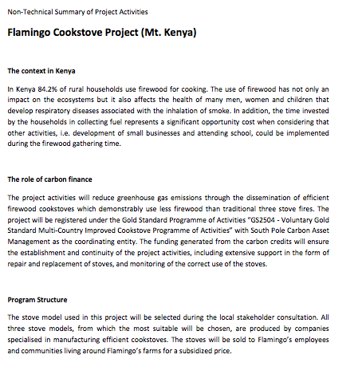

- Invitation tracking table

Category code | Organisation  (if relevant) | Name of invitee | Way of invitation | Date of invitation | Confirmation received? Y/N
B | NEMA Meru County | Bashir Salim | salimbashirzz@yahoo.com | 25/10/16 | N
B | MCA Kisima Ward | HON Joyce Karambu | Joykarambu74@gmail.com | 25/10/16 | N
B | Forest Officer-Buuri District | KFS Zonal Manager, Elizabeth Wambugu | info@kenyaforestservice.org | 25/10/16 | N
A | Madaraka Pri School | Head Teacher | nkanjamugendi@gmail.com | 25/10/16 | N
A | Maritati Pri School | Head Teacher | Letter | 25/10/16 | 25/10/16
A | Ngusichi Pri School | Head Teacher | Letter | 25/10/16 | N
A | Karimba Women | Chairman/lady | Letter | 25/10/16 | N
A | Mithatene Women | Chairman/lady | Letter | 25/10/16 | N
A | Kabubung Women | Chairman/lady | Letter | 25/10/16 | N
A | Muogene Women | Chairman/lady | Letter | 25/10/16 | N
A | Karukunku Women | Chairman/lady | Letter | 25/10/16 | N
A | Ngusichi Market | Chairman/lady | h_Kathurima@yahoo.com | 25/10/16 | N
A | Muogene Y.S.H.G | Chairman/lady | Letter | 25/10/16 | N
A | Ngusishi WRUA | Chairman/lady | info@ngusishi.org | 25/10/16 | N
A | Timau WRUA | Chairman/lady | Letter | 25/10/16 | N
C | Ms. Anne Nyatichi Omambia, PhD | Climate Change Desk Officer of the Kenyan DNA | anomambia2002@yahoo.co.uk, anomambia@nema.go.ke | 25/10/16 | N
D | Chinansi Foundation | Chithyola | chinansifoundation07@gmail.com | 25/10/16 | N
D | Climate Action Network South Africa | Lebelo | dorah@gendercc.net | 25/10/16 | N
D | NOVA Institute | Pauw | christiaan.pauw@nova.org.za | 25/10/16 | N
D | ONKE Training | Mrubata | mkhuseli@telkomsa.net | 25/10/16 | N
D | Renewable Energy & Energy Efficiency Institute | Ndhlukula | kndhlukula@polytechnic.edu.na | 25/10/16 | N
D | SouthSouthNorth | Raubenheimer | stef@southsouthnorth.org | 25/10/16 | N
D | Zero: Regional Environment Organisation | Chigwada | info@zeroregional.com | 25/10/16 | N
E | Gold Standard | Subuddhi Banthia, Senior Programme Officer, Energy and Waste  New Delhi, India | subuddhi.banthia@goldstandard.org | 25/10/16 | N
D | Kenya Clean Cookstove Association | Myra Mukulu | myra.mukulu@kenyacookstoves.org | 25/10/16 | N
D | Envirofit | Wycliffe Nyakundi | wycliffe.nyakundi@envirofit.org | 25/10/16 | N
D | Envirofit | David Small | david.small@envirofit.org | 25/10/16 | N
D | SNV | Timothy Mungai | Timothy Mungai - tmwangi@snvworld.org | 25/10/16 | N
D | SNV | Caroline Toroitich | Caroline Toroitich - ctoroitich@snvworld.org | 25/10/16 | N
D | Climate care | TomMorton | business@climatecare.org | 25/10/16 | N
D | I-smart | Tania Laden | info@livelyhoods.org | 25/10/16 | N

- Text of email invitation

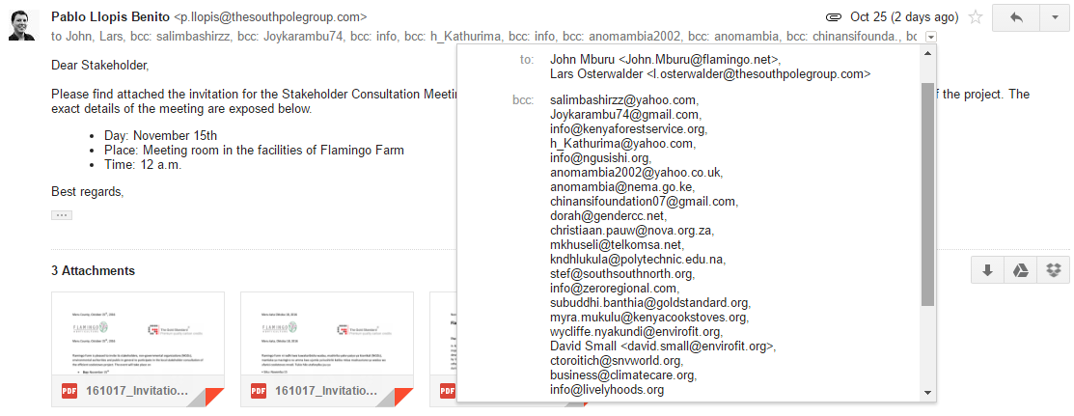
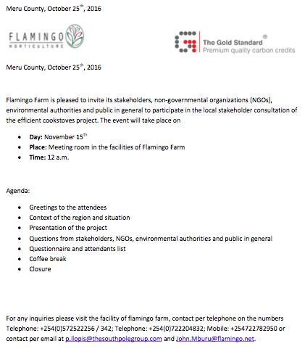

- Text of invitations to local stakeholders
Local key stakeholders were invited by letters (in Swahili) and direct phone calls.

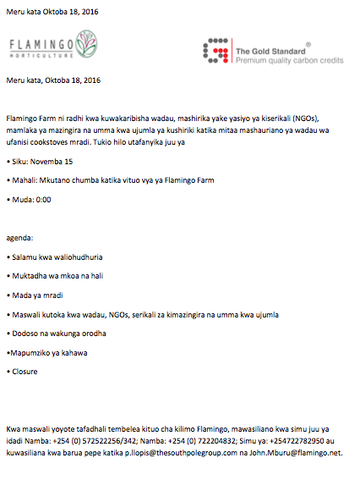
- Text of public invitations
The workers of Flamingo farm were communicated about the LSC meeting through personal communications in their workplaces.

C.2. Summary of the comments received:
- Minutes of the meeting
The LSC meeting took place as planned in the facilities of Flamingo farm in Nanyuki, Kenya. Invited stakeholders who had confirmed the participation did take part in the meeting.
Efficient cooking stove in Kenya – GS Local Stakeholder Consultation
Tuesday, November 15th, 2016
A non-technical summary of the project (in Swahili) and an evaluation form (in English/Swahili) were given to all participants at the beginning of the meeting.
- Opening
The meeting started with 30 minutes of delay due to technical problems with the projector. John Mburu, Fairtrade Liason Officer of Flamingo, officially opened the meeting by emphasizing the importance of using sustainable fuels for meeting households’ energy requirements in all communities living in the region. Mr. Mburu also gave a short introduction about the activities of Flamingo in the region.
- Explanation of the Project
John Mburu introduced the health risks related to continuous use of firewood in the kitchens, as they produce ocular and respiratory health problems. Mr. Mburu briefly introduced the need to develop a baseline survey to undertake an efficient cooking stove carbon project. He also explained that the project had selected a small group of Flamingo workers which should test two different models of stoves the project had access to and provide feedback to the project in order to make a decision on which is the most convenient model for this phase. As the feedback will be provided through questionnaires the information on this selection process can be made available to anyone having interest in consulting it.
Afterwards Pablo Llopis (South Pole Group) briefly explained about the planned registration of the project under the Gold Standard and the financing structure of the project. He also shared the initial design of the baseline survey, which consists of a questionnaire and a firewood weight measurement exercise in 120 households of selected communities around the flamingo farm.
After the project and its particularities had been explained John Mburu demonstrated the operation of one of the cooking stove models considered by the project. Unfortunately, due to logistic constraints, only one model was available at that moment.
John Mburu assisted in the translation to Swahili when this was necessary.
- Feedback Round & Questions for Clarification
The participants had the chance to ask questions and provide general feedback about the project. A summary of the questions and responses is given below in the section ‘assessment of stakeholders comments’ (combined with inputs/feedback from the evaluation forms).
The overall feedback was very positive: reduced investment in time/money invested in fuel used for meeting households’ energy needs, improved health, less soil erosion due to reduced deforestation, and conversation of the environment by reduced deforestation. The participants requested to start the project as soon as possible and the members of the WRUA offered their full support to the project because they perceived it as a very positive initiative that will preserve forests in the region and improve the water cycles.
Pablo Llopis explained that the project will initially subsidize the price of the stove until its use becomes a standard practice. The selling price of the most expensive stove considered will be 1,000 KSH. The participants received this information with interest, since some of them had expressed that the original price of the most expensive cooking stove offered is high (3,500 KSH) and that this could be an obstacle to the project.
After the question and feedback round the ‘sustainable development exercise’ was conducted. The sustainable development matrix asked the attendants to provide their opinion about the extent to which the project would have positive, negative or neutral influence in the following aspects:
- Air quality
- Quantity and quality of water
- Soil condition
- Other contaminants
- Biodiversity
- Quality of employment
- Households of the poorest
- Access to clean energy
- Human and institutional capacity
- Quantitative employment and generation of workplaces
- Access to investment
- Technology transfer and trust on technological development

In general, the project is perceived to have positive influence in all aspects that were considered in the sustainable development matrix. From the 27 questionnaires answered during the sustainable development exercise there were 288 responses of aspects declared as positive, 24 as neutral, six were not answered and six were answered as having a negative impact in any of the aspects considered. In total, a total of three persons provided responses with negative feedback, one of them providing three negative answers.
Aspects receiving negative feedback were “Access to clean energy”, “Quantitative employment and generation of workplaces”, “Quality of employment” and “Households of the poorest”. However, after reviewing the comments associated to the responses it can be stated that the negative perception respond to external factors to the project. For example, the answer showing negative perception on the access to clean energy adds a comment saying “It uses the same energy, but less in comparison” and the response on quantitative employment says “It is all self-composed”.
The project developer will consider all comments received and will make sure to reflect them in the project design while also ensuring the project participants understand the extent to which this initiative has capacity to influence the aspects reflected in the questionnaire of the sustainable development exercise.
- Discussion of Continuous Input/Grievance Mechanism
The participants were informed that the report about the LSC meeting will be made available in due time. Any additional questions or feedback can be given to Flamingo.
- Closure
Mr. John Mburu officially closed the meeting at 3:15 p.m.

The district chief of Ngusishi was not able to attend the LSC meeting but was visited in his office by the project team on Wednesday, 16 November 2016. He was very supportive and requested to be informed as soon as the cooking stove start to be distributed in the community.
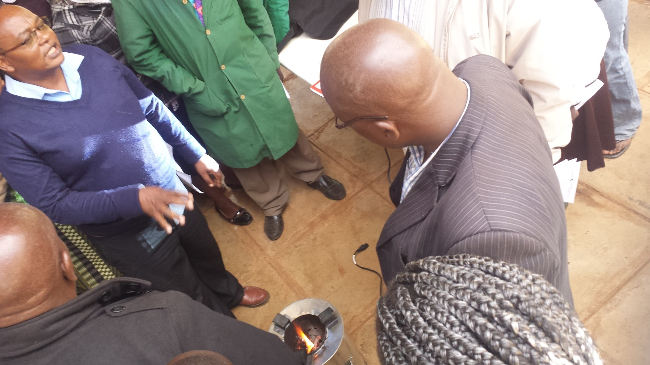
Demonstration of the operation of one of the cooking stove models considered for the project.

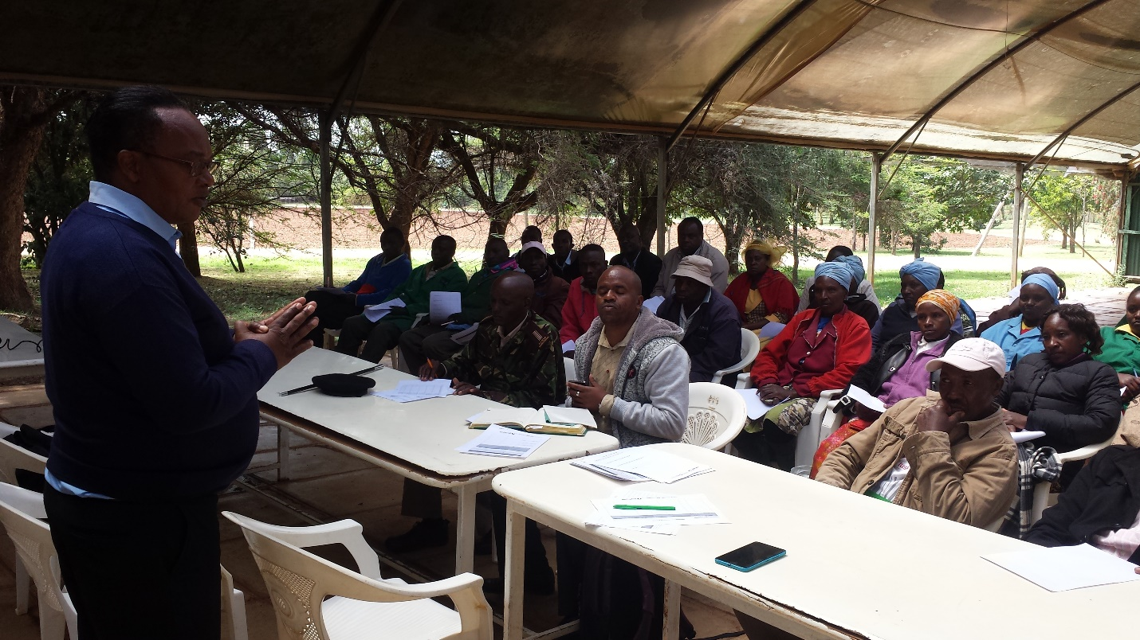
John Mburu explaining the particularities of the proposed project activities in Swahili

- List of participants
A scanned copy of the original participant list is attached in Annex 3.

Participants list
# | Category Code | Name of participant | Male/ Female | Organisation/Function | Contact details
1 | A | William Kirimi Kairi | M | Flamingo Ibis | 0795 - 174781
2 | A | Nancy Wangeshi | F | Flamingo Ibis | 0723 – 218328
3 | A | Agatha Wambura | F | Flamingo Ibis | 0710 – 196514
4 | A | Doreas | F | Flamingo Ibis | 0725 - 475191
5 | B | Edward Kirimi | M | CCM | 0723 - 512980
6 | B | Anne Jane Kaimda | F | Great Hope Secretary S-H-G | 0725 – 835712
7 | B | Momis Muriti | M | Timae Community | 0711 - 995249
8 | A | Boniface Kariuki | M | Flamingo | 0707 – 804663
9 | A | Erick Kirimi Mutwiri | M | Flamingo | 0704 - 677625
10 | A | Osman Omar | M | Flamingo Horticulture | 0113 – 324452
11 |  | Franklin Murithi | M | H/T Maritati Pry | 0729 – 143155
12 | A | Fredrick Krome | M | Flamingo | 0710 – 266771 / 0700 = 826050
13 | A | Philip Gorongo | M | Flamingo | 0705 - 899274
14 | A | Thomas Kiptabut | M | Flamingo | 0726 - 741546
15 | A | Bernard Mitambo | M | Flamingo | 0727 - 989467
16 | A | Reuben Kimathi | M | Flamingo | 0720 - 675719
17 | A | Anthony Wamai | M | Flamingo | 0727 – 819785
18 | A | Simon Hananja | M | Flamingo | 0720 - 594168
19 |  | Alice Murithi | F | Karukunku | 0724 – 131458
20 | A | Mary W. Malharia | F | Flamingo H. Culture | 0720 - 362009
21 | A | Celestin A. Magak | F | Flamingo H. Culture | 0703 – 421707
22 | A | Irene Gathigia | F | Flamingo H. Culture | 0710 – 358220
23 | A | Purity Njoki | F | Flamingo H. Culture | 0727 – 646653
24 | A | Faith Kathambi | F | Flamingo H. Culture | 0714 – 008154
25 | A | Teresa Kaburd | F | Flamingo H. Culture | 0728 - 321476
26 | A | Pamela | F | AAA Growers | 0726 - 646452
27 | A | David Mgari | M | Flamingo | 0713 – 251655
28 | A | Ruth Kenn | F | Flamingo | 0722 – 425485
29 | A | Joy Gakii | F | Flamingo Horticulture | 0728 – 462010
30 | A | Serah W. Minangi | F | Flamingo Horticulture | 0729 – 647185
31 | A | Martha Wakoryu Waharre |  | Flamingo Horticulture | 0725 – 922057
32 | A | John Kanani | F | Flamingo Horticulture | 0706 - 065574
33 | B | Murithi Muthuri | M | Ngusishi WRUA | 0722 – 172257
34 | B | Julius K. Mbiti |  | Timan WRUA | 0721 – 290373
35 | B | James Muchai |  | Teleswan WRUA | 0721 – 287131
36 | B | Raphael Ntomgal |  | WARD Administrator | 0721 – 960031
37 | B | Olocsk | F | Kisina WARD | 0728 – 455797
38 | A | Geoffrey Thirinsa | M | Flamingo | 0727 – 033698
39 | B | Peter Ntakupdi | M | WARD Admin | 0724 – 299710
40 | F | Peter Kinyn | M | Fairtrade | 0721 - 133883
41 | A | John Mburu | M | Flamingo
42 | A | Pablo Llopis | M | South Pole Group

- Evaluation forms
Scanned copies of all evaluation forms are attached in Annex 4. A sample of representative comments are presented below:

Name | Carol Kagwiria
What is your impression of the meeting? | Educative and resourceful
What do you like about the project? | Improvement of environmental impacts positively
What do you not like about the project? | N/L

Name | Raphael Ntomgal
What is your impression of the meeting? | Very educative it expands one knowledge on environmental and health issues
What do you like about the project? | It helps us to acknowledge we have better ways of conservation, cheaper and more humane to the entire fraternity, not only humans but also animals and environment.
What do you not like about the project? | I like it. The innovation is great.

Name | Boniface Kariuki
What is your impression of the meeting? | The meeting was very educative, relevant to the community.
What do you like about the project? | - Environmental conservation ideology  - The innovation on economic impact i.e., contribute to increase income for the users.
What do you not like about the project? | Nothing – the idea is perfect

Name | James Muchai
What is your impression of the meeting? | Good and educative
What do you like about the project? | Economic and environmental friendly
What do you not like about the project? | N/L

Name | Nice Murithi
What is your impression of the meeting? | To learn more and implement what is good
What do you like about the project? | I have enjoyed the lesson and I will go and teach others.
What do you not like about the project? | The price is quite high, but I will try my best and achieve the Jiko.

Name | Felix Mugambi Kibori
What is your impression of the meeting? | It was brought awareness and diversity of knowledge on how to minimize usage of firewood hence enhancing a good practice for tree growing system.
What do you like about the project? | It brings knowledge and products very close to the people.
What do you not like about the project? | No enough commodities to the people so when we pass the information we will have nothing to offer to the willing parties.

Name | Anne Jane Kaimda
What is your impression of the meeting? | I’m happy to see the new project from South Pole, and also free education.
What do you like about the project? | I’m happy because of this Jiko
What do you not like about the project? | I’m happy and enjoyed everything was taught

Name | Joy Gakii
What is your impression of the meeting? | The meeting was good because we have learnt much on how to reduce CO₂ generated/emitted from fuels due to global warming.
What do you like about the project? | - The stove uses less firewood  - Less smoke is produced
What do you not like about the project? | N/A

Name | Cellestin A. Magak
What is your impression of the meeting? | - Improved standard on living  - It will help in changing usage of firewood through saving the forest as a resource, eliminate wastage, have a healthier nation
What do you like about the project? | - Lead to global change, new ways and methods of cooking.  - Pioneers to pass information to the (…) through (…) the project for the community to see it’s significance.
What do you not like about the project? | - Limited access, other communities would still not be able to access the jikos for use. It should be left open to all.

Name | Fredrick Krome
What is your impression of the meeting? | Of great importance with much explanation on how to improve on living standards.
What do you like about the project? | It improve a technology from the traditional way of cooking to a safer cooking method through introduction of firewood stoves with affordable cost.
What do you not like about the project? | N/A

Name | Sarah Gibson
What is your impression of the meeting? | Good
What do you like about the project? | How the jiko saves energy and it does not need me around for it to cook.
What do you not like about the project? | Nothing

- Assessment of stakeholders comments
Stakeholder comment | Was comment taken into account (Yes/ No)? | Explanation (Why? How?)
Why is this stove better than the current heating system (three-stone fire)? | Yes | The three-stone fires normally waste a lot of the heat that is contained in the firewood. Using an efficient cooking stove will allow you to use less firewood for cooking the same amount of food.
Does everyone have access to the project stoves? | Yes | Yes. The stoves are available in the market and can be purchased by anyone. In addition, during the initial phases of the project we will offer a subsidy to selected users.
How much does the stove cost? | Yes | The two stoves models being currently tested by the project have a specific market price. However, and in order to facilitate the expansion of the local market for improved cooking stoves, the project will subsidize at least the first 1,200 stoves distributed.
What happens if the efficient stove breaks down? | Yes | The management team of the project will make sure that spare parts of stoves are available locally. Stove users should communicate to local distributors when they wish to purchase a spare part so the project management team can make sure that enough supply is available.
Will the project sell also firewood? | Yes | No. This project’s focus is on the distribution of efficient cooking stoves.
How are selected the project participants? | Yes | The project focuses on providing access to people using firewood for cooking and having a relationship with Flamingo farm. However, other persons using firewood for cooking and not having relationship with Flamingo can also participate in the project. The project managers have selected villages nearby the Flamingo farms around Mt. Kenya where the project will be implemented
How long is the project? | Yes | This project will last for, at least, seven years. However, it aims to set up a sustainable supply of fuel-efficient cookstoves so that the technology will be available also after the end of the carbon project.
What happens with the profits of the project? | Yes | The project generates revenue from the selling of carbon credits which are used to pay for management, materials and operation, monitoring and auditing costs. If after covering all costs the project would create revenues the project managers have identified actions the project could invest in. All these actions are related with the availability of renewable and sustainable energetic resources for the communities around the Flamingo farms.
What will happen if we don’t have any firewood to use? | Yes | The project will not be able to generate carbon credits anymore and then it should be suspended. However, this project focuses on providing affordable and sustainable sources of energy for communities, and this also includes providing periodic capacity building to the users of firewood on how to manage their own energetic resources in a sustainable way.
Is it only for Flamingo employees? | Yes | No, but Flamingo employees are a specific focus of this project.
When will we get our stove, and when will the project start? | Yes | The project has already started. This stakeholders meeting is the very first milestone of the project. Currently, a test with some users is being done to select the most appropriate stove for the project. The dissemination of subsidized stoves should start in early 2017. The monitoring of stoves use will start during the second quarter of 2017.

C.3. Report on how due account was taken of any comments received and on measures taken to address concerns raised:
The stakeholders’ comments will be considered while designing the details of the project implementation design. Attention needs to be given to a proper training of end users on the use of the selected cooking stoves and the most suitable condition of the fuel used.

C.4. Report on the Continuous input mechanism selection:

To be added
 | Method Chosen (include all known details e.g. location of book, phone, number, identity of mediator) | Justification
Continuous Input / Grievance Expression Process Book
Telephone access
Internet/email access
Nominated Independent Mediator (optional)

All issues identified during the crediting period through any of the Methods shall have a mitigation measure in place that should be added to the monitoring plan.

C.5. Report on stakeholder consultation feedback round:
For the Stakeholder Feedback Round the following steps are planned:
- An invitation for the Stakeholder Feedback Round will be sent out to all stakeholders who were invited and/or attended the Local Stakeholder Consultation on November 15th, 2016.
- The project documentation, as well as further supporting documents, will be made available on the webpage of South Pole Carbon and Gold Standard.
- A hardcopy of the project documentation will be made available at the office of Flamingo Horticulture Ltd. in Timau, Kenya.

Annex 1

CONTACT INFORMATION ON ENTITY/INDIVIDUAL RESPONSIBLE FOR THE micro--scale VPA

Organization: | South Pole Carbon Asset Management Ltd.
Street/P.O.Box: | Technoparkstrasse 1
Building:
City: | Zurich
State/Region:
Postfix/ZIP: | 8005
Country: | Switzerland
Telephone: | +41 43 501 35 50
FAX: | +41 43 501 35 99
E-Mail: | info@thesouthpolegroup.com
URL: | thesouthpolegroup.com
Represented by:
Title: | Senior Consultant
Salutation: | Mr.
Last Name: | Osterwalder
Middle Name:
First Name: | Lars
Department:
Mobile:
Direct FAX:
Direct tel: | +251 912 79 58 17
Personal E-Mail: | l.osterwalder@thesouthpolegroup.com

Annex 2 – Information regarding public funding
See separate ODA declaration form

Annex 3 - Scan of list of participants to the Stakeholder consultation
Annex 3 is provided as separate file

Annex 4 - Scans of feedback received
Annex 4 is provided as separate file

Annex 5 – Baseline report
Annex 5 is provided as separate file

http://www.goldstandard.org/sites/default/files/documents/gs-simplified-micro-scale-cookstove-meth-2013.pdf
http://cdm.unfccc.int/DNA/fNRB/index.html

